It is now 0035 and your aPTT has resulted at 147. Align the symbols and the numbers on the cipher to read the labels and select the bottle whose label states the right time to draw the next aPTT, has the right dose, and the right bolus.

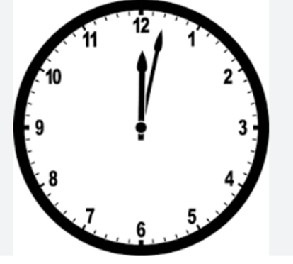

**Find this clock**

All labs WNL. Initiate heparin infusion at 0900

Find the initial bolus and Program me.

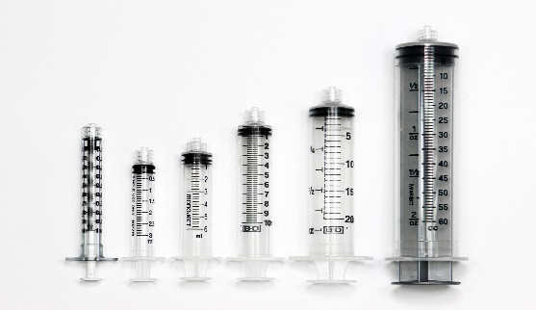

[This Photo](https://wtcs.pressbooks.pub/nursingskills/chapter/5-2-math-basic-concepts/) by Unknown Author is licensed under [CC BY](https://creativecommons.org/licenses/by/3.0/)